*Level 0*

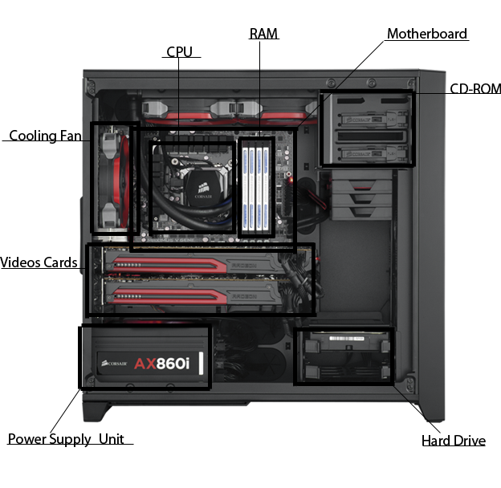

CD-ROM- Media Driver(s)

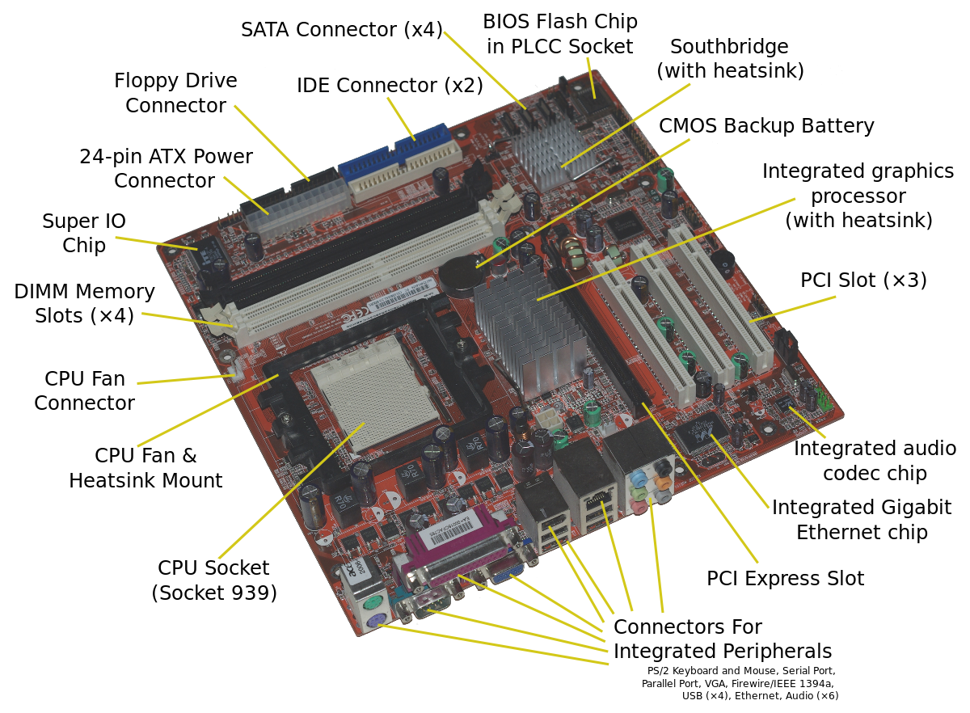

* <https://en.wikipedia.org/wiki/Motherboard>

1. (Also Refer To First Picture In Document)

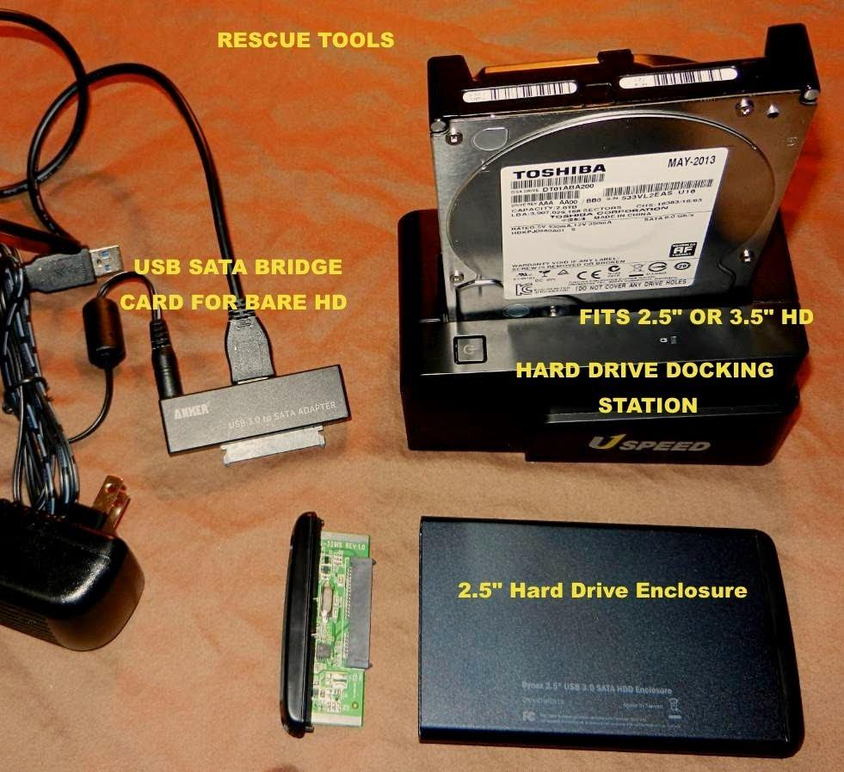

-https://www.youtube.com/watch?v=5cTZBMi-XwQ

Media Drive (Optical Disk Drive In Picture)

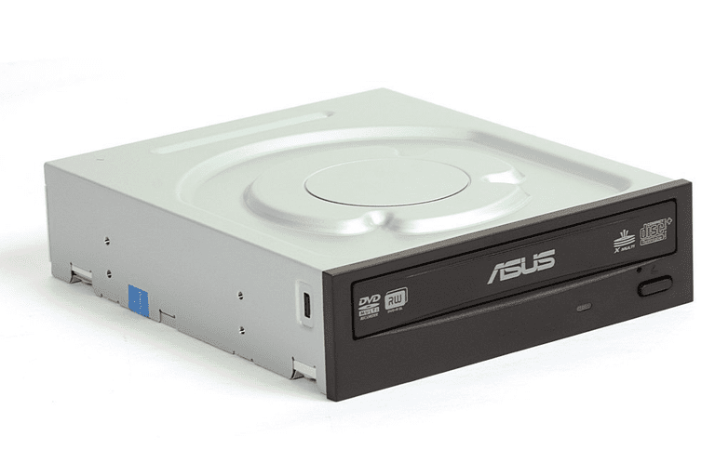

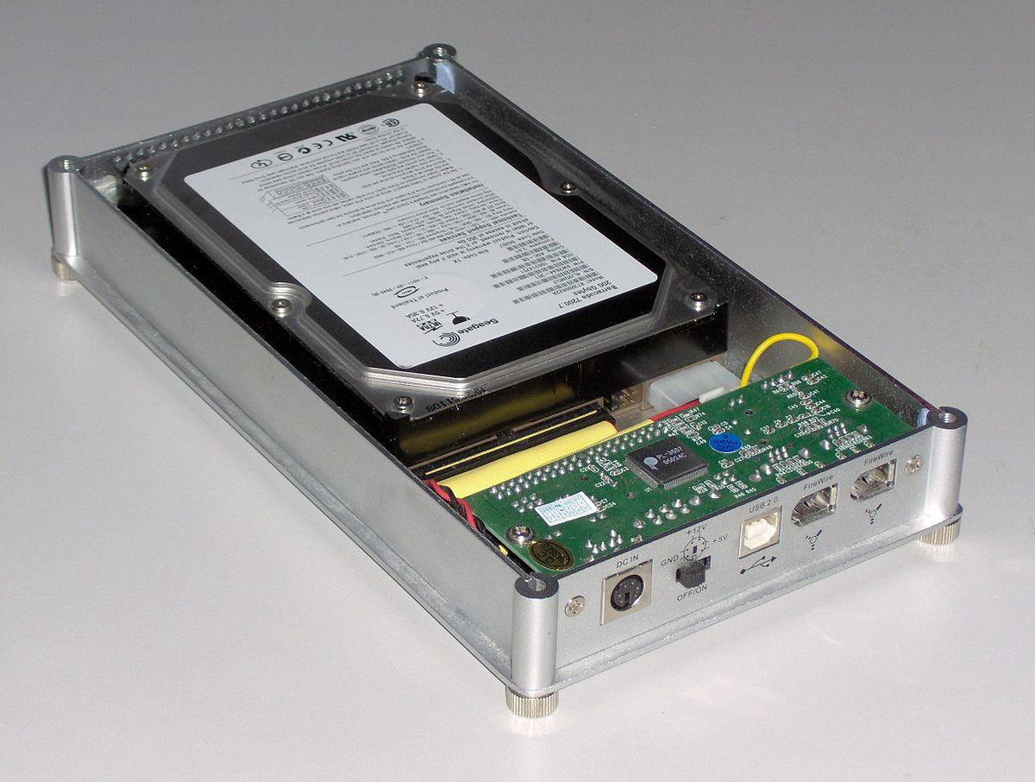

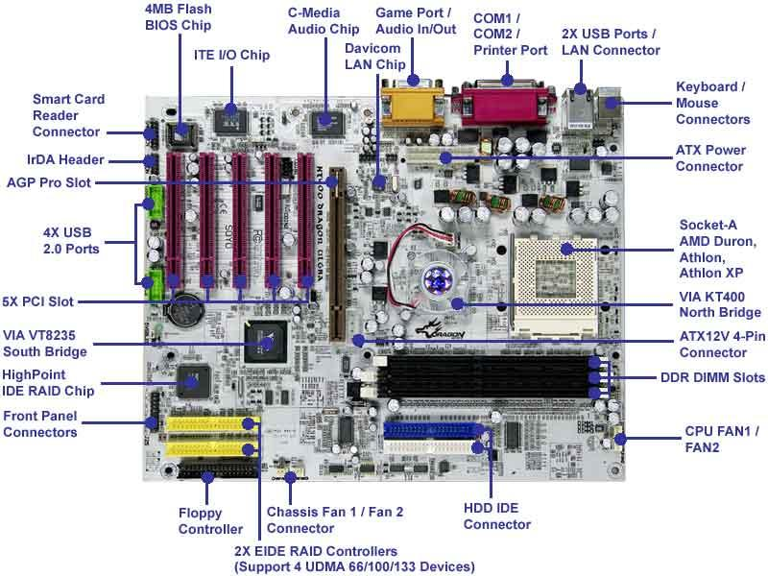

-https://www.anandtech.com/show/1001/2

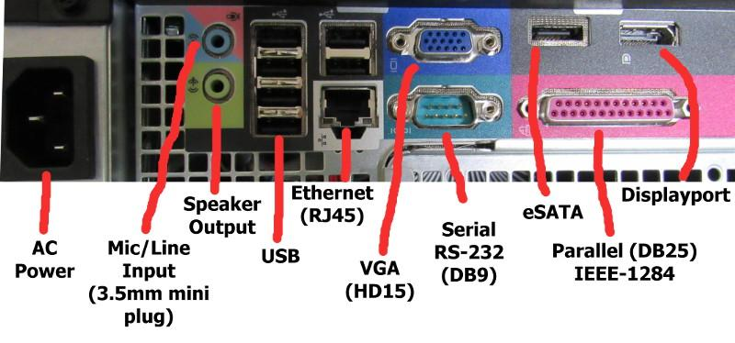

-https://www.ramelectronics.net/connecters.aspx

*Level 1*

1. – First mainframe computer developed by IBM, Automatic Sequence Controlled Calculator (ASCC), solved addition and multiplication in <6 seconds, used thousands of vacuum tubes to operate.

-IBM- RAMAC 305 used ascending stack of aluminum discs covered with iron oxide (Data Bank), with this, data was magnetically coded allowing random data to be retrieved from a storage file.

-UNIVAC (Universal Automatic Computer) developed by Dr. J. Presper and Dr. John W. Mauchly, was meant to be a computer that didn’t use the card-punching technique was developed in the late 1940’s and early 1950’s;4 years to build, cost ~$1,000,000 to produce, & took up 352 ft2.

- Small, low cost 1440 Data Processing System produced in 162 for small and medium businesses to be able to afford

-System/360, announced during 1964 in April had virtually unlimited storage, instant retrieval capabilities which allowed minutely decision making information about information management. Allowed companies to put data processing applications into one information management system for organization. “System/360 included in its central processors 19 combinations of graduated speed and memory capacity. Incorporated with these were more than 40 types of peripheral equipment. Built-in communications capability made the system available to remote locations, regardless of distance.”

b) -RCA 501 Computer, 1959, could control 63 tape drives at the same time.

-IBM 1401, 1960.

-IBM 7094, Early 1960’s.

-IBM SABRE, 1962

-IBM 7094ㅍ, 1963

- IBM System/370, upgrade System/360, 1970

-IBM 3340 disk unit, 1973

-IBM 5100 portable computer, 1975, which was a 50-pound desktop that could be used by engineers, analysts, statisticians, and other problem-solvers.

-IBM System/38, 1978, general purpose computer, uses semiconductor technology

c) Mainframe computers are used by banks because they allow the banks to process all their data and customers transactions easily. Insurance companies use mainframes because they have a lot of data from multitude of customers to store and process. Healthcare buildings use mainframes, so that they can keep all their data secure and minimize work for transactions. The government uses mainframes to store and analyze the huge amounts of data that they have on not only their citizens, but things like . Mainframes help pilots make sure that planes reach their destination in the most effective way because the mainframe would have all the flight networks. Also, retailers use mainframes to process transactions and keep track of their inventory. The mainframe computer that is used by these companies is a computer called Big Iron.

2. a) The first supercomputer was the Control Data Corporation 6600 which was designed by Seymour Cray and only had a single CPU. It was released in 1964. the CDC 6600 was the size of four side-to-side filing cabinets. It cost $8 million back in the 1960s which can be converted to approximately $60 million today and operated at up to 40MHz. This computer was cooled by Freon that was circulated in pipes. The CPU of the CDC had 10 parallel functional units that and each unit was dedicated to a different task. Another super computer which was one of the first was the Cray 1 and it used integrated circuits. This computer had an increased word size of 64-bit with the performance of 136 megaflops which is faster than the CDC 6600 that had 3-megaflops. The Cray was shaped like a “C” because it improved the performance of the computer because the distance between the modules would be shorter, and it would allow it to run fast at a speed of 80MHz.

b) MPP or massively parallel processing, is the coordinated processing of a program by multiple processors that work on different parts of the program in which each processor is using its own operating system and memory. An "interconnect" arrangement of data paths allows messages to be sent between the processors. An MPP system is also known as a "loosely coupled" or "shared noting" system.

A network computer is a computer with minimal memory, disk storage and processing power and is designed to connect to a network, especially the Internet. The reason for network computers is that many users who are connected to a network don't need all the computer power they get from a typical personal computer. Instead, they can rely on the power of the network servers.

c) An example of a quantum computers is the Turing machine which was developed by Alan Turing in the 1930s, it is a theoretical device that consists of tape of unlimited length that is divided into little squares. Each square can either hold a symbol (1 or 0) or be blank. A read-write device reads these symbols and blanks, which gives the machine instructions to execute a certain program. In a quantum Turing machine, the tape and the read-write head exist in a quantum state. Normal Turing machines can only perform one calculation at a time, a quantum Turing machine can perform many calculations at once.

Modern quantum computers, similar to a Turing machine, work by manipulating bits that exist in one of two states: a 0 or 1. Quantum computers aren't limited to just two states, they can encode information as quantum bits, or qubits, which can exist in superposition. Qubits represent atoms, ions, photons or electrons and their respective control devices that are working together to act as computer memory and a processor. A quantum computer can contain multiple states simultaneously and it has the potential to be millions of times more powerful than today's most powerful supercomputers.

This superposition of qubits is what gives quantum computers their inherent parallelism. Parallelism allows a quantum computer to work on a million computations at once, while your desktop PC works on one. A 30-qubit quantum computer would equal the processing power of a conventional computer that could run at 10 teraflops which is trillions of floating-point operations per second. Today's typical desktop computers run at speeds measured in gigaflops which is billions of floating-point operations per second.

3. a) The first IBM computer was the IBM 5150 and it was introduced in August of 1981. This PC was able to process information faster than the mainframes of the 1960s and you could hook up a TV set to it to display the information in that form. It would also process text and store more words than a large cookbook. The price of the IBM 5150 was $1,600 then which is around $2,100 now.

b) There were many prototypes before the IBM PC. Some examples being, the IBM 5100 Portable Computer in September 1975 it weighed approximately 50 pounds, the 5100 desktop computer, which was almost had the same storage capacity as the IBM 1130 and was as easy to use as an IBM Selectric Typewriter. After the IBM 5100 was made, there were two more models made, which were small computers called the IBM 5110 and the IBM 5120.

c) The first apple computer was introduced in 1975 and it was a box of lights and circuit boards. It connected to a TV which served as a monitor and had a typewriter as a keyboard. This is different from a PC because a PC had a monitor which was not a TV and a normal keyboard.

d) The way that PCs have changed over time is that the older PCs were, the larger in size they were, the circuits were not sophisticated, and the PCs would overheat very often. Then, PCs stopped using vacuum tubes and started to use transistors which made the computer faster and overheat less often, and not as significantly. Also, the PCs were starting to decrease in size because they were using transistors instead of vacuum tubes. After that, the PCs were starting to use integrated circuits which made the PCs a lot faster. Now, in the more modern PCs, they have better storage and increased speed. Another thing is that in more modern PCs there is a graphics card which is something that old PCs did not have.

*Level 2*

1. a) The first CPU chip released was the intek 4004 and it was released on November 15, 1971. It was designed by Federico Faggin, Ted Hoff, and Stanley Mazor. The 4004 was a 4-bit, 16-pin microprocessor that operated 740KHz at eight clock cycles per instruction cycle. This chip was capable of 92,000 instructions per second. The CPU had less than 2,300 transistors in it.

b) An integrated circuit is a complete circuit with many components and connections between them, and it is made in a microscopically tiny form on the surface of a piece of silicon. Before the ICs were invented, computers used transistors or vacuum tubes.

c) The CPU chips have been getting faster and getting better performance since the 8086 was made. After the 8086 was made there was a better chip that was made, and it was called the 80286 and the performance of this chip doubled that of the 8086. The 8086 was made with 134,000 transistors. Then, the Intel 386 chip came out and it had 275,000 transistors and was Intel’s first 32-bit processor. The Intel 386 processor could go up to 4GB of storage. Another chip was made, and it was even better than the Intel 386 chip and it was called the Intel 486. The intel 486 chip had 1.2 million transistors in it and it had up to 4GB of memory.

2. a) The way that RAM memory is used differently than Core memory is that in early computers, RAM would use a hard drive to store the data from the RAM before the computer is powered off. While Core memory would use an electric current to remember the data. So, in Core memory, the data is stored within it and with RAM it is stored on a hard drive.

b) Moore’s law is an observation that was made by the Intel co-founder Gordon Moore in 1965. Stated in this law he stated that he noticed the number of transistors per square inch on an integrated circuit is doubling each year. Moore’s law would predict this trend will continue in the future. The way that RAM would follow Moore’s law is that memory for computers us getting better as years go on. Also, the memory is getting better, therefore, computers are not being slow due to bad memory.

c) The difference between RAM memory and external memory is that in RAM memory it uses electricity to store all the data and when the computer is powered off, all this data is lost. While external memory would save all the data and when let you access the data again instead of it being deleted after. Also, the range of RAM sizes would be 256MB to 32GB, while the range of hard disk sizes can be from 500GB to 8TB.

d) The way that RAM memory evolved over time is that before RAM there was magnetic core memory and then in the late 1960s- after RAM was invented- people were making changes to RAM by making it fit in smaller places and making it have a larger memory size. Another thing is that there were different types of RAM that were made, one of which was Dynamic RAM that used periodic refreshment and it was the type more commonly found on computers. The other type of RAM that was made was Static RAM. Also, in the future people are trying to create a RAM that does not erase its data after the computer is powered off.

3. a) VGA is short for Video Graphics Array and it was a popular display standard. The VGA was developed by IBM in 1987, at that time, it gave 640 x 480 resolution colour displays with a refresh rate of 16 Hz and 16 display colours.

b) The graphics that came before VGA graphics were EGA which stands for Enhanced Graphics Adapter. The resolution for EGA graphics are 640 x 350 pixels and it had 16 display colours.

c) The first 3D graphics cards were introduced in 1995 and were plugged into an expansion slot. The 3D graphics cards acted as pass-through between the main processor and the display.

d) The way the graphic cards are evolving over time is that the performance of these cards is getting better over the years. These cards are getting smaller and exponentially more powerful. The appearance and design of the graphic cards have been getting bug changes. The manufacturers have been also upgrading PCB components and experimenting with different cooling techniques. Some of the early graphics cards were the Monochrome Display Adapter made by IBM in 1981 which was able to display 80 columns and 25 lines of text. Then in 1983, Intel made the Intel iSBX 275 Video Graphics Controller Multimode Board which was able to have a resolution of 256 x 256 with a display of eight colours. In the 1990s they made the 3dfx Voodoo1 with a 3D processor that had 4MB of RAM and a 50MHz core clock. One of the latest graphic cards is the Nvidia GeForce GTX 1080 that was made in 2016 and it has 8GB of GDDR5X VRAM and can compete against CrossFire systems with a standalone solution for 4K gaming.

*Level 3*

1. The operating system is the most important software that runs on a computer. The operating system manages the computer's memory and all of its processes. Also, the operating system manages all the software and hardware and, it allows you to communicate with the computer without you knowing how to speak the computer's language (Different types of codes/often binary). Another thing is that the operating system would allow all the programs to have what they need to work. For example, access to the CPU, memory and storage.

1. The difference between an operating system and software program is that an operating system would let you run the computer, manage users and install programs, while a software program is something that is installed onto a compatible operating system for ulterior functions and services.

b) A driver is a group of files that enables hardware devices to communicate with the computer’s operating system. If there were no drivers then the computer would not be able to send and receive signals/data correctly to a hardware device.

c) A service is a program that would run in the background. In windows, it would control many things such as, printing, sharing files, communicating with Bluetooth devices, checking for software updates, and many other functions/work.

2. a) DOS is short for Disk Operating System and DOS is an operating system that runs from a hard disk drive. The way DOS is related to windows is that when Microsoft first introduced Windows, it was a graphical user interface for MS-DOS and you would have to type “WIN” at the DOS prompt to launch a windows program. Then, Windows changed from a GUI program running under DOS to a full operating system that became a default operating system for most computers that were not Macintoshs or Linux running computers.

b) The first version of Windows was Microsoft Windows 1.0 and it was introduced in November 20, 1985. Microsoft Windows 1.0 had several programs such as MS-DOS file management, Paint, Windows Writer, Notepad, Calculator, Calendar, Card File, a clock, and the game Reversi. Also, Microsoft Windows 1.0 had drop-down menus, scroll bars, icons, and dialog boxes made programs easy to use and learn/simpler to navigate. Another thing is that to use Microsoft Windows 1.0 you were required to have a minimum of 256 kilobytes of storage space, which was two double-sided floppy disk drives, and a graphics adapter card. Additionally, it needed a hard disk and 512 KB memory were recommended for running multiple programs or when using DOS 3.0 and higher by Microsoft.

c) Between the Apple operating system and the Windows operating system there was a lot of competition between the two companies. Apple was known as the first inexpensive and simple personal computer in 1976. Then in 1990, when Windows 3.0 came out it was a more user-friendly and less expensive system than the Mac in the 1990s. Then, in 1995, Apple created the Macintosh Clone Program to compete with Windows and IBM. The program allowed a licensed Mac operating system on other computers. This would mean that Windows users can purchase a Mac OS and use it on their PC instead of Windows.

d) Windows was the first to have a graphical user interface. Then the first Windows operating system came out in 1985 and it was called Windows 1.0. In 1987 Windows 2.0 came out and it allowed you to overlap applications and it introduced the “Minimize” and “Maximize” options for the tabs/applications you had open. Then in 1990 Windows 3.0 came out and a few years later in 1992 windows 3.1 came out which was the first of the series to have a 16-bit operating system. Next in 1995 Windows 95 came out it had a proper marketing drive from Microsoft and it had a “Start” button and taskbar, this was a turning point as it made computers far easier to use than anytime in the past. Then in 1998 Windows 98 came out and it was a hybrid of a 16 and 32-bit operating system. A couple years later in 2000 Windows 200 came out. In 2001 Windows XP came out and it had a more interactive user interface, better hardware support, and more multimedia capabilities. Then in 2007, Windows Vista came out, which had better security. In 2009 Windows 7 came out and then three years later in 2012 Windows 8 came out which made big changes to the user interface that better suited tablets. Lastly the current version of windows that is being used now is Windows 10 and it was released in 2015. This operating system was the most secure enterprise operating system ever, until a bug allowed hackers to easily get a rat onto peoples’ systems to steal their information, for which there was a patch released in 2016.

3. a) UNIX is an operating system that was developed by Brian Kernighan in the 1960s with the members of the MULTICS team at the Bell Laboratories. UNIX is an operating system that is a stable, multi-user, multi-tasking system used for/in servers, desktops and laptops.

b) LINUX is an open-source operating system, and this means that it can be modified and distributed by anyone in the world. It is different from other operating systems such as Windows because Windows can only be modified by the company that owns it. While LINUX is free and there are many different versions that you can choose from and change yourself. The way that LINUX is related to UNIX is that LINUX is a UNIX-like operating system that was co-developed by Linus Torvalds and thousands of other people.

c) The way that UNIX is related to the Apple operating system is that the Apple OS was based the UNIX operating system.

*Level 4*

* Complete

<https://docs.google.com/presentation/d/1_7VHfnyHtMzi8rFHmAAtul00g6gQWJvqL0TksTA8BVY/edit?usp=sharing>

Works Cited

“1973.” IBM Archives: 1970s, www-03.ibm.com/ibm/history/history/year_1973.html.

“A Brief History of CPUs: 31 Awesome Years of x86.” Pcgamer, PC Gamer THE GLOBAL

AUTHORITY ON PC GAMES, 14 Apr. 2009, www.pcgamer.com/a-brief-history-of-cpus-31-awesome-years-of-x86/.

Anthony, Sebastian. “Intel 4004, the First CPU, Is 40 Years Old Today.” ExtremeTech, 15 Nov. 2011, www.extremetech.com/computing/105029-intel-4004-the-first-cpu-is-40-years-old-today.

Anthony, Sebastian. “The History of Supercomputers.” ExtremeTech, 12 Apr. 2012, www.extremetech.com/extreme/125271-the-history-of-supercomputers.

Beal, Vangie. “Network computer.” What is Network Computer? Webopedia Definition, www.webopedia.com/TERM/N/network_computer.html.

Byrne, Michael. “Memory Is Holding Up the Moore's Law Progression of Processing Power.” Motherboard, 1 July 2014, motherboard.vice.com/en_us/article/3dkkx8/memory-is-holding-up-the-moores-law-progression-of-processing-power.

Deffree, Suzanne. “Microsoft Ships Windows 1.0, November 20, 1985.” EDN, www.edn.com/electronics-blogs/edn-moments/4401825/Microsoft-ships-Windows-1-0--November-20--1985.

“Evolution of Microsoft Windows through the Years.” 1E, 29 Nov. 2016, www.1e.com/evolution-of-windows/#windows2012.

Fisher, Tim. “What Is a Windows Service and How Do You Use Them?” Lifewire, www.lifewire.com/what-is-a-service-4107276.

History of Mainframes. ocw.usu.edu/English/Technology_for_Professional_Writers/chapter3.pdf.

Hoffman, Chris. “What Is Unix, and Why Does It Matter?” How-To Geek, How-To Geek, 22 Sept. 2016, www.howtogeek.com/182649/htg-explains-what-is-unix/.

“How Do Integrated Circuits Work?” Explain That Stuff, 25 Jan. 2018, www.explainthatstuff.com/integratedcircuits.html.

“How Does Computer Memory Work?” Explain That Stuff, 2 Oct. 2017, www.explainthatstuff.com/how-computer-memory-works.html.

“How Graphics Cards Have Evolved over the Years.” MyBroadband Trusted in Tech, mybroadband.co.za/news/hardware/196964-how-graphics-cards-have-evolved-over-the-years.html.

“How Quantum Computers Work.” HowStuffWorks, 8 Dec. 2000, computer.howstuffworks.com/quantum-computer1.htm.

“Is Linux a Unix?” Unix & Linux Stack Exchange, unix.stackexchange.com/questions/4091/is-linux-a-unix.

“Mac vs. Windows: The History of OS Competition.” Singapore Blog | Singapore Community - Vodien, 20 Oct. 2017, www.vodien.com/blog/technology/mac-vs-windows-the-history-of-os-competition.php.

“Magnetic Core Memory.” MagLab, nationalmaglab.org/education/magnet-academy/watch-play/interactive/magnetic-core-memory-tutorial.

Mainframe, www.thocp.net/hardware/mainframe.htm.

“Microsoft Windows History.” Computer Hope, 15 Sept. 2017, www.computerhope.com/history/windows.htm.

“Moore's Law.” Investopedia, 24 Nov. 2003, www.investopedia.com/terms/m/mooreslaw.asp.

Rawlinson, Nik. “Apple Was 41 Years Old in April, Here's Some History.” Macworld UK, 25 Apr. 2017, www.macworld.co.uk/feature/apple/history-of-apple-steve-jobs-mac-3606104/.

Thakur, Dinesh. “Dinesh Thakur.” Computer Notes, ecomputernotes.com/fundamental/terms/enhanced-graphics-adapter.

“The Birth of the IBM PC.” IBM Archives: The Birth of the IBM PC, www-03.ibm.com/ibm/history/exhibits/pc25/pc25_birth.html.

“The Birth of the IBM PC.” IBM Archives: The Birth of the IBM PC, www-03.ibm.com/ibm/history/exhibits/pc25/pc25_birth.html.

“The Development of RAM Technology.” Bright Hub, 22 Jan. 2010, www.brighthub.com/computing/hardware/articles/60758.aspx.

Roudie. “The Difference between RAM and Hard Drive | Techtorium NZIIT.” Techtorium, 5 June 2017, techtorium.ac.nz/the-difference-between-ram-and-hard-drive/.

“The Evolution of Computers.” Norton Security Online, www.nortonsecurityonline.com/security-center/evolution-of-computers.html.

“The History of the Modern Graphics Processor.” TechSpot, www.techspot.com/article/650-history-of-the-gpu/.

“The IBM PC's Debut.” IBM Archives: The IBM Personal Computer, www-03.ibm.com/ibm/history/exhibits/pc25/pc25_intro.html.

“The Modern Mainframe: Embracing Cloud & Mobile.” Network Computing, 8 Oct. 2014, www.networkcomputing.com/applications/modern-mainframe-embracing-cloud-mobile/2024231092.

Tozzi, Christopher. “Mainframes Rule: A Look at 6 Industries Where the Mainframe Is Still King.” Syncsort Trillium Software Blog, 13 Dec. 2017, blog.syncsort.com/2017/06/mainframe/6-industries-mainframes-king/.

UNIVAC, 18 Mar. 2018, www.thocp.net/hardware/univac.htm.

“UNIX Introduction.” UNIX Tutorial - Introduction, www.ee.surrey.ac.uk/Teaching/Unix/unixintro.html.

“What Is a Device Driver?” Computer Hope, 26 Apr. 2017, www.computerhope.com/jargon/d/driver.htm.

“What Is an Operating System?” GCF LearnFree, www.gcflearnfree.org/computerbasics/understanding-operating-systems/1/.

“What Is DOS (Disk Operating System)? - Definition from WhatIs.com.” SearchSecurity, searchsecurity.techtarget.com/definition/DOS.

“What Is the Difference between an Operating System and a Program?” Data Recovery & Computer Repair Services in Rockville- VitalTech MD, vitaltechmd.com/what-is-the-difference-between-an-operating-system-and-a-program/.

“What is MPP (Massively parallel processing)? - Definition from WhatIs.Com.” WhatIs.com, whatis.techtarget.com/definition/MPP-massively-parallel-processing.

“What Is Unix?” Computer Hope, 26 Apr. 2017, www.computerhope.com/jargon/u/unix.htm.

“What Is VGA (Video Graphics Array)?” Computer Hope, 30 Oct. 2017, www.computerhope.com/jargon/v/vga.htm.

“Computer History Museum.” *The First Mainframes*, www.computerhistory.org/revolution/mainframe-computers/7/166.

“Mainframes Introduction 2.” *IBM Archives: Mainframes Introduction 2*, www-03.ibm.com/ibm/history/exhibits/mainframe/mainframe_intro2.html.

*Technology For Professional Writers*. IBM, ocw.usu.edu/English/Technology_for_Professional_Writers/chapter3.pdf.